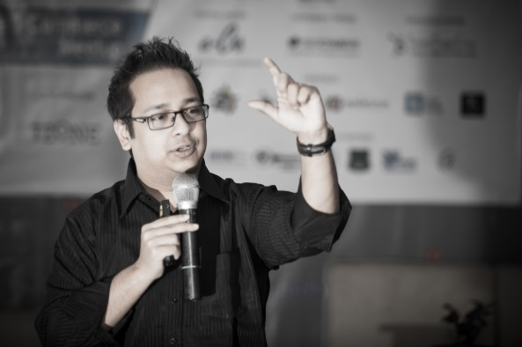

**G. Sumdany Don**

D

**on** is the Chief Inspirational Officer at Don Sumdany Facilitation & Consultancy. ([www.DonSumdany.com](http://www.donsumdany.com/)) He completed "Facilitation and Training Skills" with certified Master-trainer Sarah Krasker at the Master Trainer Institute (France) (<http://mastertrainer.ch/>), and also trained under global facilitator and brand-marketing guru Trini Amador from BHC Consulting (USA) (<http://www.bhcconsulting.com/>). For over four years, Don had the privilege to work for Philip Morris International (PMI), a Fortune 500 Company and represented one of the top 10 global brands in the world. Don trains people to communicate with customers effectively, build great teams, and inspire strong leadership among different managers. Currently he is training up 1200+ full-time employees of Grameenphone, while Chevron, Perfetti, Holcim, Envoy Group and so on are some of his regular clients.

The Class Valedictorian 2008 from ULAB, Don also conducts career build-up workshops at East West University (EWU), and the University of Liberal Arts Bangladesh (ULAB). He has conducted sessions in Dhaka University, JU, IBA JU, NSU, AIUB, BRAC, Manarat, ASA University and several others. He also offers corporate client training sessions for Bdjobs, Prothom-Alo Jobs, Business Express, and for Chartered Accountants in ICAB. He has trained over 10,000+ people so far. Don also has his own live radio show called "Donspiration" at Colours FM 101.6 and he writes for The Daily Star and has his own weekly column called "Level Up with G. Sumdany Don" published every Thursday in the SHOUT magazine section.

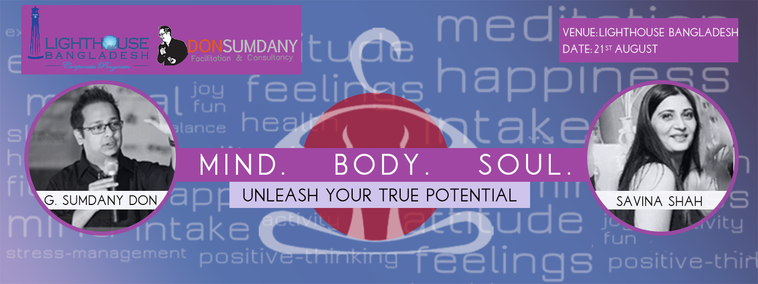

S

avina is a yoga, meditation, reiki healer, & theta healing master & practitioner. It gives her great joy to be able to utilize this platform to share with you all her knowledge & demonstrate these unique forms of discipline that has had remarkable effect on her life, giving her a sense of fulfillment & accomplishment & she deeply wishes that you all should benefit from it too.

**Yoga:** A gift from our forefathers & the glorious past, it is simple routine combining breath control, meditation, & body postures that has the power to almost magically lift your spirits, relax, & condition your physical & psychological state doing wonders to one's body & soul.

**Reiki:** An exquisite touch healing process, in which the practioner channelizes strong energy into the person stimulating & activating the natural healing process stored within the patient thereby restoring their physical, emotional & mental well - being.

**Meditation:** A method of training the mind, it has the ability to singularly calm, improve focus/ concentration levels, most importantly lending a therapeutic effect to the person significantly improving their quality of life.

**Theta Healing:** Yet another very powerful & effective healing modality, in which the practioner tries to dig deeper & deeper into the patients mind using the Theta brain waves, wherein the practioner is able to reach & tab into the subconscious mind of the patient / client & work on the belief systems which could have originated from either core level, history level, genetic level or the soul level itself.

Currently, she is associated with & takes pride in working with the BRAC UNIVERSITY. Teach yoga & meditation to the university students once in a week & twice a week, instructing & imparting the yoga knowledge & wisdom with the BRAC faculty.